The Model Process of BMP Implementation Souq.Com

Name
Institution of Affiliation
Instructor
Date

The Model Process of BMP Implementation Souq.Com
For an efficient BMP implementation in Souq.com, and to ensure that the product works out and responds expectedly, an effective process of implementation should therefore and must be followed to achieve the positive results. Souq.com being the most widely known and recognized site in the Egyptian and Saudi region, depicts that, if a commendable effort is applied towards further digitalizing of the organization, great and unbelievable outcomes in terms of services and products deliveries can be experienced not only in the Arabs but also in various diverse countries and headed to global marketing (Smith et al., 2009). The perfect process to give exemplary results is as outlined and evaluated.
Discussion
BMP Opportunity Evaluation
In this initial phase of the overall process, the user will ascertain the best Business Management Process (BMP) that is most likely to be effective and efficient. Souq.com a distinguished Egyptian and Saudi site selling millions of products of different categories like household goods, electronics, consumer health beauty and fashion is fully interested and have met the necessary arrangement conditions to ensure the application of the Business Process Management discipline. Souq.com BPM preparation assessment will provide the organization an appropriate mechanism to measure the capacity to adapt, transform and embrace a coordinated performance (Mc Nett et al., 2010)
The organization; Souq.com having a deep and clear understanding of the maturity profile for the whole process, will make it easier to have a perfect design of the BPM implementation approach which subsequently discourses the most essential successful elements which strengthens the aspect of business process management and the overall sustainable value.
In the assessment phase, an analysis of key areas such as those with higher chances of risk factors and potential resistance is carried out to ensure that the process works out effectively from the beginning of the process. The current situation at Souq.com therefore needs to be improved and devising the BMP mechanism and completely implementing it will consequently mark an improvement (Mc Nett et al., 2010).
Business Management Process (BMP) Preference / Prioritization
Prioritization of the Souq.com BMP will entail a further feasibility assessment criterion aimed at assessing whether the process is conceptual and of a higher degree necessary to be developed and implemented (Jang et al., 2013). Prioritizing the Souq.com BMP in order to verify the suitability of business process management to be implemented will be based on the four issues addressed hereunder;
Place in order the catchments on the basis of need.Souq.com should categorize the potential Business Management Processprospects within the mega priority catchments. Recognize the most suitable BMPs. This should be based on issues like cost of implementation and maintenance and the effectiveness of that particular BMP as well.
For the fact that Souq.com is in the United Arab Emirates region, it will also be necessary to cultivatethesite-specific execution schemes which should be more efficient if based on the specific sites assessments (Jang et al., 2013). Such strategies while implementing BPM should be incorporated as this will ensure the organization and precisely Souq.com achieve its core objectives and acquire a large number of clients not only in the Egyptian and Saudi region but globally as well.
The responsible managerial group has the mandate and full responsibility to choose the Souq.com objectives and should thereafter make sure that the entire process contributes and gives support to the achievement of the organizations’ goals and set objectives. Making the proper priorities and giving suitable preference will ensure that the whole process achieves the objectives.
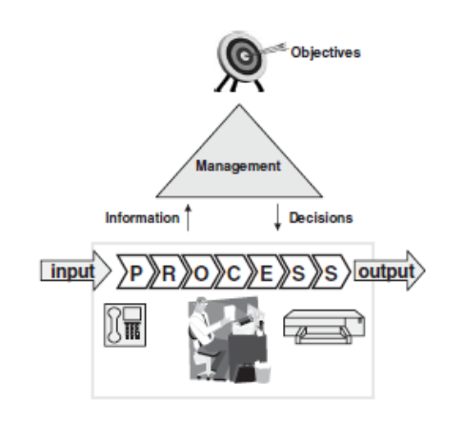

Generally, the process practices which are accordingly affiliatedand in line with the set objectives, goals and organizational strategies perfectly attain the targeted objectives and are effectively sustainable all through the process of implementation.It is always significant to put in to considerations the weakness, strengths, constraints and the likelihood of present processes whilst articulating the strategies on point.
Right Selection of the Applicable BMP
In this stage the applicable BMP will be distinguished from the prioritized list andthe most appropriate one to serve for the intended purposes of Souq.com will be recommendedand consequently put forward to await the implementation (Anta et al., 2006). Determining the best and efficient BMP selectionfor Souq.com will be dependent to three key factors to the whole development project; that is, people, procedure and as well the technology. The three key elements in addition to the management mode will get the BMP process for Souq.com efficiently working and serving the intended purpose.
Process- the availability of a suitable and substantial level of the organization innovative practices as well as the remodels interrelated to Souq.com approach and the recognition of the significance of every process in the online venture. A proper understanding of the organizational processes will ensure an appropriate selection of the most applicable BMP for Souq.com.
People-each and every venture either profit oriented organization or a non-profit entity has individuals as the key drivers and determinants of the ventures’ going concern. For instance as Souq.com progresses to the prime of process administration, the entity comprehends that people are the major aspects and determiners to implementation of the proposed first-hand processes.
The organization however should hold the apposite performance management and dimension structures all through the key processes. The said Process management need be proactive and furthermore make a move headed to being predictive,in spite of being reactive. Amid other elements, this behavioral elementall turn aroundthe peoples’aspects of Business ProcessManagement project.
Technology- This entails the supportive tools and elements for the people and general processes but however does not always precisely refer to the BPM programs, applications and components.
Project management- a BPM implementation without a properly run scheme, the overall implementation is only in vain and destined to finallyfail (Anta et al., 2006). The afore-mentioned elements will be considered Souq.com management and stakeholders while making a decision on the selection of the suitable BMP for the entity.

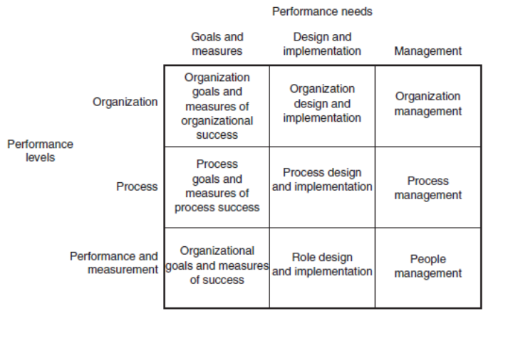
The BMP Implementation
After successfully selecting the applicable BPM, the next phase will involve the incorporation of all the analysis of Souq.com processes, optimization, the business approach, automation and the workflow scheme as well. The precise BPM implementation for Souq.com will typically commence by outlining the procedure involved in the process as it will then be simpler to ascertain the areas requiring improvements, aspects to be automated and keeping track (Hwang et al., 2004).
This particular phase is very crucial and should not be done in haste as would lead to an overall inefficiency and negative impacts on the venture as well as sapping the organizations resources. However, the product should be implemented in the shortest time possible and ensure that it will serve the intended purpose.
Documentation
This is the last stage for Souq.com BMP implementation and the implemented Business management process should be documented. Arriving at this stage of documentation, means that the BMP has successfully passed through the necessary steps from the initial phase to this final step. The Business Management Process is at this point ready to be used and efficiently work out for both the benefit of the entity and the clients as well (Hwang et al., 2004). This final stage marks and is a sign of the efficient work carried out by the participants, stakeholders and the Souq.com organization.
Conclusion
Souq.com having satisfactorily followed and adhered to the whole process as captured above, will subsequently manage to meet and achieve the objectives already put in place as the implementation process begun. The achievement of an effective BMP will not only be advantageous to the organization alone but more so to the respective customers of the entity. An entity’s achievement is marked and gauged according to the satisfaction presented and derived by the final users of the commodities and products offered by the company. Souq.com will be marked as conducting an attractive business as the entity will have to meet the needs and expectations of the customers by having successfully implemented the BMP and it is through the afore-mentioned process in the body context.

References
Anta, J., Peña, E., Suárez, J., & Cagiao, J. (2006). A BMP selection process based on the granulometry of runoff solids in a separate urban catchment. Water Sa, 32(3), 419-428.
Hwang, J., Chapin, S., Mantar, H., & Okumus, I. (2004, April). An implementation study of a dynamic inter-domain bandwidth management platform in DiffServ networks. In 2004 IEEE/IFIP Network Operations and Management Symposium (IEEE Cat. No. 04CH37507) (Vol. 1, pp. 321-334). IEEE.
Jang, T., Vellidis, G., Hyman, J. B., Brooks, E., Kurkalova, L. A., Boll, J., & Cho, J. (2013). Model for prioritizing best management practice implementation: sediment load reduction. Environmental management, 51(1), 209-224.
McNett, J. K., Hunt, W. F., & Osborne, J. A. (2010). Establishing storm-water BMP evaluation metrics based upon ambient water quality associated with benthic macroinvertebrate populations. Journal of Environmental Engineering, 136(5), 535-541.
Smith, C. M., Nejadhashemi, A. P., & Leatherman, J. C. (2009). Using a BMP Auction as a Tool for the Implementation of Conservation Practices. Journal of extension, 47(4), 1-10.

